**Apache Kafka**-Apache Kafka is an open-source distributed Event Streaming Platform

**Features of Apache Kafka**

* High Throughput
* Fault tolerance (replication technique)
* scalable
* Apache kafka is distributed system it act as a cluster.
* one microservice produces the msg and sent to the Apache Kafka broker and another microservice consumes this message from the Kafka broker,
* when we use Apache kafka which is used in the distribution system When we use Apache kafka in the production environment we have to create at least 3 kafka brokers in the kafka cluster.
* The producer can create any message. This message can be an event, stream of the record, plaintext, string, JSON.
* there is also a term called kafka topic it is created inside the kafka cluster and the consumer will subsribe that topic.
* zookeeper will maintain the state of this Kafka broker in Kafka cluster also zookeeper will maintain the configuration of all the topic producers and consumers.
* apache kafka is fault tolerance if one broker fails another broker will maintain that.
* There are some traditional messaging systems like active MQ and rabbit MQ. It works well as a replacement for this messaging system.

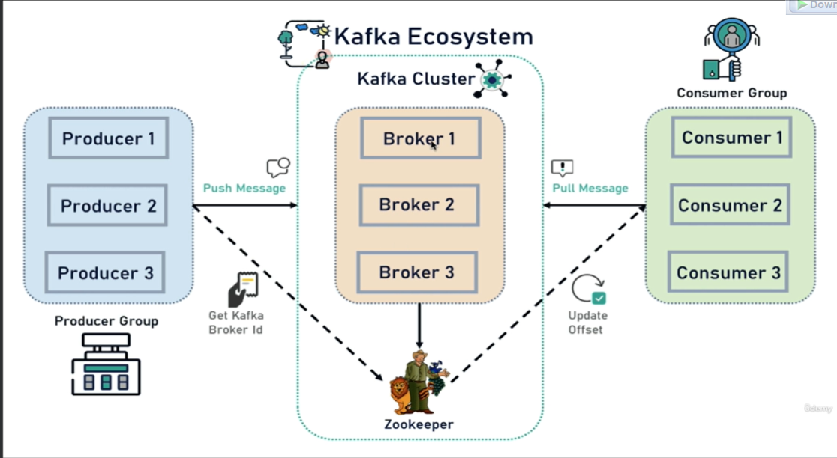

**Components Of Apache Kafka**

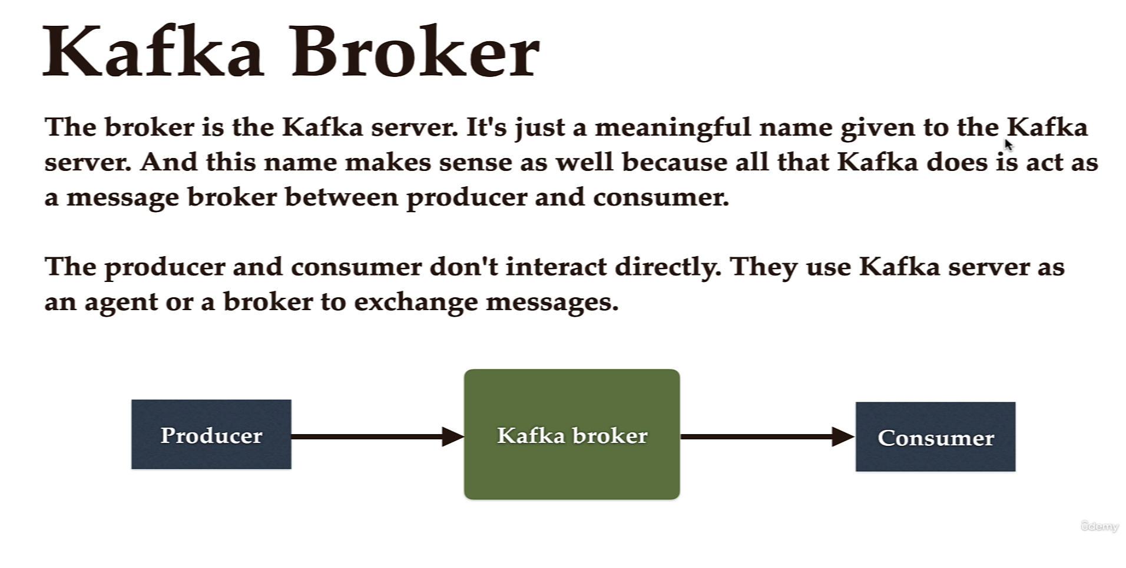

* Kafka Topic :it will provide security mechanisms to get data from broker to consumer.it catagories the data in to topics

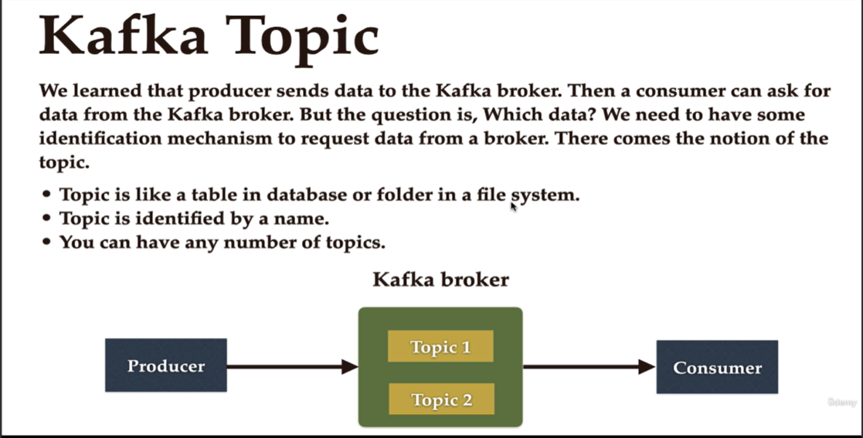

* Topic subdivided into partition so that huge data can store over distributed network  
  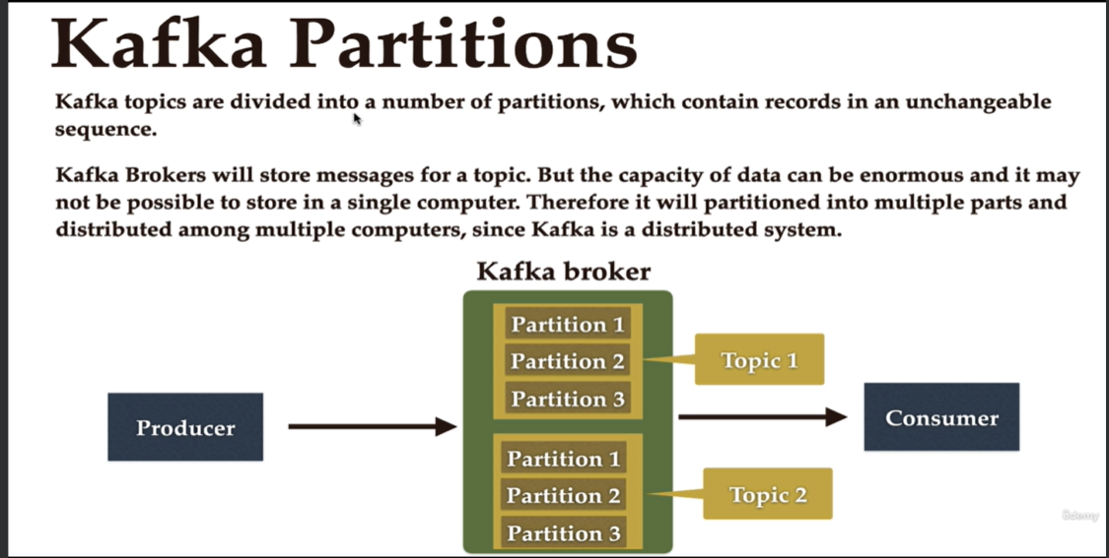
* Offset:

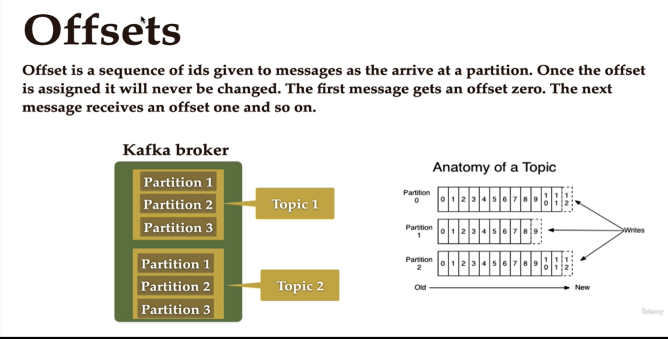

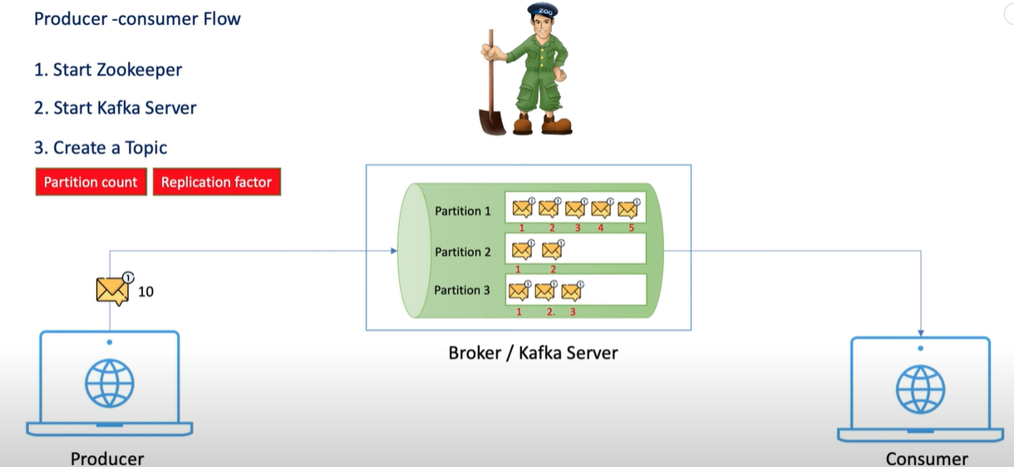

How to run with Kafka

* First go to Apache kafka file and download Kafka and put the download in the root folder as the name is concate so error we get to long size so put in d drive
* After that go to only folder and open cmd and run first apache kafka zookerper by  
  bin\windows\zookerper config\zookeper .properties file check proper name
* Then use new cmd and run server same way  
  \kafka-server-start.bat config\server.properties(9092 port it will reanning)
* **How we can create topic in kafka**kafka-topics.bat --create --topic quickstart-events --bootstrap-server localhost:9092

**OR**

bin\windows\kafka-topics.bat –bootstrap- server localhost:9092 --create --topic shubham-topic --partitions 3 --replication-factor 1

* How to get the list of Topics created

-bin\windows\kafka-topic.bat –bootstrap-server localhost:9092 --list

* **How to see our topic description**\kafka-topics.bat --describe --topic quickstart-events --bootstrap-server localhost:9092

Topic: quickstart-events TopicId: sQ9HLQbZRtyX9tPmlUmnLQ PartitionCount: 1 ReplicationFactor: 1 Configs:

Topic: quickstart-events Partition: 0 Leader: 0 Replicas: 0 Isr: 0

* HOW TO PRODUCE THE TOPIC USING PRODUCER SUB CONSOLE  
  bin\windows\kafka-console-producer.bat --topic quickstart-events --bootstrap-server localhost:9092
* HOW TO CONSUME THE TOPIC USING CONSUMER CONSOLE  
  bin\windows\kafka-console-consumer.bat --topic quickstart-events --from-beginning --bootstrap-server localhost:9092

IF I REMOVE --FROM BEGINNING IT WILL TAKE ONLY FROM WHEN YOU INITIALIZE

What you have to add in application. property is   
  
server.port=8082  
spring.kafka.producer.bootstrap-servers=localhost:9092  
spring.kafka.producer.key-serializer=org.apache.kafka.common.serialization.StringSerializer  
spring.kafka.producer.value-serializer=org.apache.kafka.common.serialization.StringSerializer

